Sample format and instruction for manuscript preparation for International Forum of Medical Imaging in Asia 2011

R. Fukuhara¹, S. Mori², M. Kumagai², H. Haneishi³
¹ Chiba University, Graduate School of Advanced Integration Science, Chiba, Japan
² National Institute of Radiological Sciences, Research Center for Charged Particle Therapy, Chiba, Japan
³ Chiba University, Research Center for Frontier Medical Engineering, Chiba, Japan

Abstract
Submission of the final manuscript for publication in the conference proceedings is required for all accepted papers. Recommended length of each manuscript is two or more pages but less than 10MB. The deadline for submission is December 15th, 2010. This is a sample form of manuscript. Although the detailed format is described below, an easy way is just to open this WORD file and replace this content by the author’s one.
Page size: A4 (210mm x 297mm)
Margin
Top: 25mm
Bottom: 35mm
Left: 25mm
Right: 25mm
Font type and size
Title: Arial, 14pt
Author’s name and affiliation: Times, 10pt
Heading: Times, bold, 10pt
Text, table, figure caption: Times, 10pt
Final file must be PDF. In order to add header and footer at the conference office, please give the submitted PDF file such permission. Normally created PDF file seems to have such permission.
Hereafter, an example of manuscript, not instruction of manuscript preparation is presented.

Keywords: radiotherapy, patient set up, epipolar geometry, guideline

Introduction
It is necessary to perform a patient set up accurately in radiotherapy[1]. Generally the radiotherapy is performed repeatedly and the patient set up is done by manual operation at every treatment. At this time, the patient position is adjusted by comparing the bi-plane X-ray images acquired at the last treatment position and those acquired at the current treatment positioning. Theoretically it is possible to estimate the three dimensional position of the target from the bi-plane images. However, since it is difficult to find the corresponding points from the two images, we cannot often take the advantage of the bi-plane imaging. The purpose of this study is to propose a method for assisting operator’s accurate three-dimensional positioning.

Method
In finding a corresponding point from bi-plane images, we propose to draw a guideline in an image based on the epipolar geometry [2]. Once the geometry of a bi-plane imaging system is determined and known, an epipolar line in the second image corresponding to a feature point in the first image is useful as the candidate. This idea is frequently used in finding corresponding points or areas in stereo optical images. Although this idea is usually used in automatic search, in this paper, we use it for operator's manual search because the search of corresponding points in X-ray images is sometimes ambiguous and hard to complete by computer only. On the other hand, the display of candidates of the corresponding point as a guideline should greatly help the operator's search. In the following, the operation procedure is presented.
A schematic illustration of the epipolar-assisted search is shown in Fig. 1. A point in an X ray image corresponds to a line that runs through that point and the X ray source. Thus selecting a feature point in the X ray image #1 of a bi-plane X ray imaging system means that existence of the feature point is limited to a line in the 3D object space. That line can be projected onto the X ray image #2 of the bi-plane X ray imaging system and overlaid on the original X-ray image as shown in bottom left in Fig. 1. An operator can choose a feature point from the line displayed in the image #2.
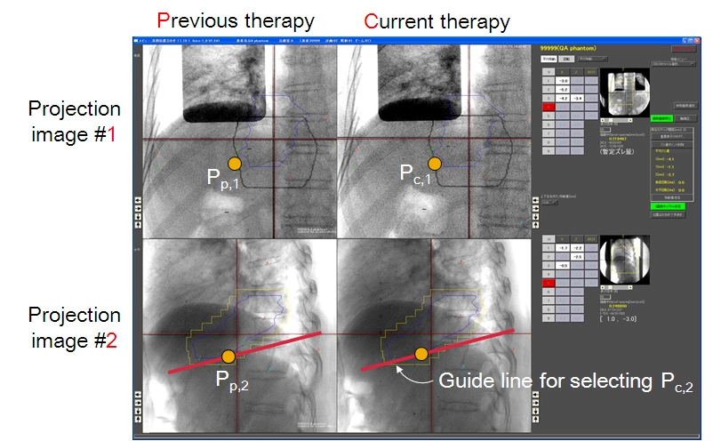
Fig. 1. A schematic illustration of the epipolar-assisted search

This process is first done for the image pairs of the previous therapy and Pp1 and Pp2 are determined. Next, from the projection image #1 in the current therapy, the operator choose a feature point, Pc1, that he/she recognized to be the same point as the feature point, Pp1, in the projection image #1 in the previous therapy. Then, a guide line is displayed in the projection image #2 in the current therapy and the operator choose a point Pc2 that he/she recognized to be the same point as the feature point, Pp2. From images coordinates in the two images, the 3D position of the feature point is determined for both previous and current therapy.
The above process is repeated for multiply selected feature points. After sets of 3D position of feature points are obtained, parameters of a rigid body transformation are determined by the least square fitting.

Computer simulation
In order to investigate the accuracy of the method, computer simulation was conducted. Two aspects of this method were studied: (1) impact of the position of the feature points especially the distance from iso-center and (2) impact of the error of feature point selection. As shown in Fig. 2 a numerical phantom was used. This phantom consists of two sizes of cubes with a common center inside a cubic object space (400x400x400 voxels). One voxel has a dimension of 0.5 x 0.5 x 0.5 mm³. 16 vertexes were used as feature points and corresponding points were selected manually. Accuracy was evaluated in three cases (1) all 16 points were used; (2) only eight points of small (inside) cube were used (3) only eight points of large (outside) cube were used.
In the second simulation, assuming there is some error in manually selecting a feature point from the current image which should be the same as the feature point as the previous therapy. This error was approximately given by adding random position error ranging from -2.0 to 2.0 mm for each coordinate to each estimated 3D position of the feature point. Ten time trials were repeated and the average accuracy was evaluated.

Results
Impact of the position of points selected
Fig.2 bottom left shows the result. While the number of points used for positioning was 8 inside, 8 outside, and all 16, the evaluation of position accuracy was done at all 16 points and mean error was evaluated for all cases. For all cases, mean error less than 0.4 mm was achieved. If only eight points are selected for positioning, mean errors were around 0.3mm or larger, but the standard deviation was larger for eight inside points than eight outside points. This suggests that the feature points should be selected from a wider region in the object space as far as a rigid body transformation model is valid.

Impact of the error in choosing the corresponding points
Fig.2 bottom right shows the result. The accuracy got worse than the case of error free in choosing the corresponding points. However, we found that if outer eight points were used, the mean accuracy of less than 1 mm was achieved.

Fig. 2. Detail of the numerical phantom and experimental results.

Conclusion
A technique for assisting operator’s three-dimensional positioning in radiotherapy has been proposed. Effectiveness of the method was confirmed and fundamental properties in positioning accuracy were investigated through computer simulation. Currently, we are ready to perform an additional experiment using physical head and torso phantoms to study the validity of the proposed method.

References
[1] P. J. Keall, G. S. Mageras, J. M. Balter, et al.: The Management of Respiratory Motion in Radiation Oncology, Medical Physics 33, 3874-3900, 2006.
[2] O. D. Faugeras: Three-Dimensional Computer Vision: A Geometric Viewpoint, MIT Press, Cambridge, MA, 1993.

